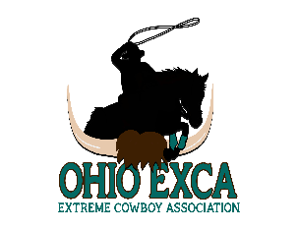
GUEST LIABILITY RELEASE FORM

WARNING
A Horse is a large animal and may be unpredictable and dangerous at times. Extreme caution should be taken in their presence. Participants assume inherent risk of equine activities. Ohio House Bill 56 enacted 3/3/97 to enact Section 2035.40 of the Ohio Revised Code relative to qualified immunities from civil liability for equine activity, sponsors, participants, professionals, and other persons in connection with harm sustained by equine activity participants from inherent risk of equine activity.
PARTICIPATE AND RIDE AT YOUR OWN RISK
Equine activities are recognized by Ohio Law as inherently dangerous. In signing below, participants and parents or guardians of participants under the age of 18 waive all claims for liability as defined by Section 2305.321 of the Ohio Revised Code OHIO EXCA, its officers and agents will not be held liable for any loss or injury to any animal, participant or their possessions.
- Participants understand that there are risks inherent in dealing with horses and ponies (equine activity). For example, Participants understands that some of the inherent risks include:
- The propensity of an equine to behave in ways that may result in injury, death, or loss to persons on or around the equine.
- The unpredictability of an equine’s reaction to sounds, sudden movements, unfamiliar objects, person, or other animals.
- That there may be hazards, including, but not limited to, surface or subsurface conditions.
- The possibility of a collision with another equine, another animal, a person, or an object.
- The potential of an equine activity Participant to act in a negligent manner that may contribute to injury, death or loss to the Participant or other persons, including, but not limited to, failing to maintain control over an equine or failing to act within the ability of the Participant.
2. This waiver Agreement is made and entered into in the State of Ohio and shall be enforced and interpreted under the courts and laws of the State of Ohio and providing a release under the Section 2305.40 (C) of the Ohio revised Code.

PARTICIPANTS PRINTED NAME ( IF OVER THE AGE OF 18YR) PARTICIPANTS D.O.B

ADDRESS CITY STATE ZIP

PHONE NUMBER EMAIL ADDRESS

SIGNATURE (IF OVER THE AGE 18YR) DATE

FOR GUESTS UNDER THE AGE OF 18, PLEASE FILL OUT THE PARENTAL CONSENT FORM BELOW.

PARENTAL CONSENT
For Participants under the age of 18, I, the undersigned parent or legal guardian of the child listed below, have read the above Waiver, Release, and Indemnity Agreement, and agree to its terms on behalf of my child and myself. I understand that by signing below, I am giving up substantial rights on behalf of my child and myself.

CHILDS PRINTED NAME: CHILDS D.O.B

PARENT/GUARDIAN PRINTED NAME: PARENT/GUARDIAN SIGNATURE

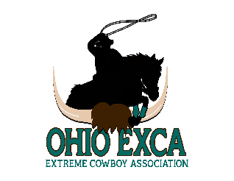
DATE PHONE NUMBER

WWW.OHIOEXCA.COM

